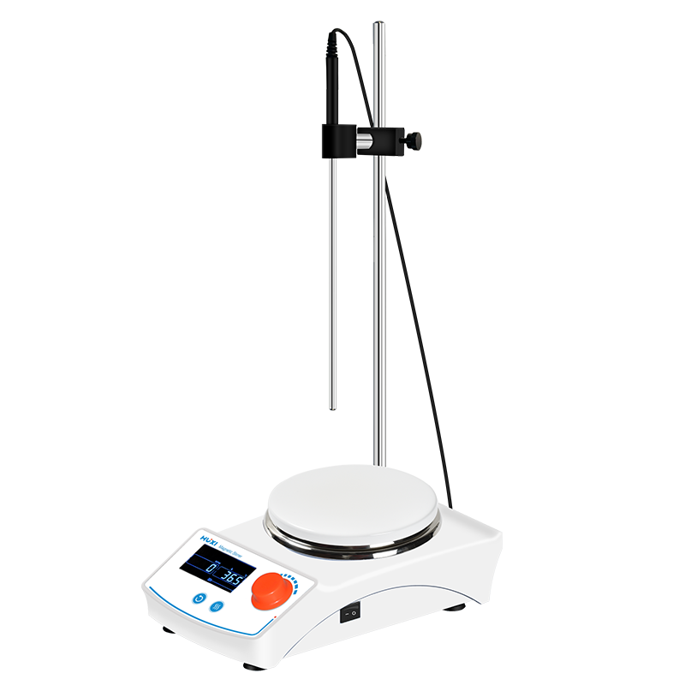

# **HMS-205D Hotplate Magnetic Stirrer**

# **Shaker**

# HT-S330 **Rotary Shaker**

**Application：**

HMS-205 Series Heated Magnetic Stirrer is specially developed and designed for applications with higher requirements on handling capacity, temperature and power. The upgraded Heated Magnetic Stirrer has better performance, stronger function and wider application range, which is suitable for stirring or heating and stirring at the same time, and the viscosity is not very large for liquids or solid-liquid mixtures.

**Main Features：**

* Stainless steel ceramic coated working plate surface is chemical resistant and pollution free;
* Wide range of temperature control up to 350°C;
* Mica sheet heating high temperature insulation corrosive thermal conductivity superior, more uniform heating;
* DC brushless motor, low noise, low maintenance, smooth operation and long service life;
* Adopting LCD backlit display, convenient for data setting and monitoring in operation, LCD display real-time display of temperature, speed and running time.
* Heating function is controlled separately, and the button is highlighted when heating is on, which is convenient to operate;
* Aluminum die-casting ceramic coated working plate with superior resistance to abrasion, corrosion and high temperature oxidation;
* Dual heating control circuits, which can continue to maintain temperature stability when one heating circuit fails;
* The knob is equipped with operation locking and anti-misoperation function, which prevents accidental change of operation status and improves experimental safety;
* Pressed aluminum sealed thermal insulation shell effectively prevents liquid and gas from entering the interior of the instrument and protects circuit components from corrosion.

**Technical Parameters：**

|  |  |
| --- | --- |
| Model | HMS-205D |
| Item No. | 1002020001 |
| Power Supply | 220V |
| Frequency(Hz) | 50~60 |
| Timer Range | 0~99h99min |
| Motor type | DC brushless motor |
| Display Mode | LCD |
| Motor Power(W) | 600 |
| Motor Output Power(W) | 15 |
| Heating Output Power (W) | 550 |
| Speed Range(rpm) | 100-2000 |
| Max capacity(L) | 20 |
| Working plate diameter(mm) | 145 |
| Working plate material | Stainless Steel Ceramic Coating |
| Heating method | Mica sheet |
| Temperature control | RT+5~350℃ |
| Temperature control accuracy(℃) | 0.1 |
| Over temperature protection(℃) | ≤420 |
| Exterior Temperature sensor | PT1000 |
| Sensor temperature control accuracy(℃) | 0.2 |
| Temperature control accuracy(℃) | 0.1 |
| Temperature set accuracy(℃) | 0.1 |
| Stirring bars range | 20~80MM |
| Allowable ambient temperature | 5-40 |
| Allowable ambient humidity(%) | 80 |
| Instrument Size(mm) | 165*280*105 |
| Packing Size(mm) | 425*390*200 |
| GW(kg) | 5.4 |
| NW(kg) | 4 |